GO OUT WITH A FANG
‘Dracula: A Comedy of Terrors’ to open at Albuquerque Little Theatre
BY KATHALEEN ROBERTS ASSISTANT ARTS EDITOR
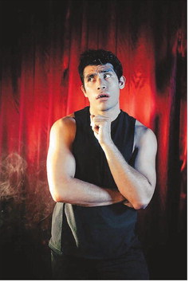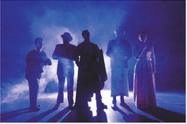
“Dracula: A Comedy of Terrors” churns Mel Brooks, Monty Python and “The 39 Steps” into a blender and spits out Bram Stoker’s vampire tale into a gender-bending romp.
A cult favorite online, the show will open at the Albuquerque Little Theatre on Friday, Oct. 11, running through Oct. 27.
Five actors play more than a dozen roles in this bloodcurdling send-up of Bram Stoker’s Gothic classic.
When her sister Mina falls ill with a mysterious blood disease, Lucy Westfeldt and her fiance, Jonathan Harker, enlist the help of famed female vampire hunter doctor Jean Van Helsing.
In the treacherous mountains of Transylvania, a meek English real estate agent takes a harrowing journey to meet a new and mysterious client, who also just happens to be the most terrifying and ferocious monster the world has ever known. Van Helsing and company chase Dracula from Transylvania to the British countryside to London and back.
Audiences can expect a fast-paced farce, said director Robb Sisneros.
Originating in Canada, the play ran off-Broadway and closed in January in a limited run.
“It became such a cult favorite that many regional theaters and universities wanted the rights,” said Sisneros. “We’re one of the very first groups outside of the original production.”
“Dracula: A Comedy of Terrors” has a content warning that includes unwanted sexual advances, sensuality, simulated sex scenes, coarse language and mature themes. ALT recommends it for patrons 11 and older.
Photos:
From left, Kristen Walsh, Isaac Carrillo, Jacob Chavez, Brent Whitted and Devoney Wilhite star in “Dracula: A Comedy of Terrors.” COURTESY OF PONIC PHOTOGRAPHY
Jacob Chavez is Dracula in Albuquerque Little Theatre’s production of “Dracula: A Comedy of Terrors.” COURTESY OF PONIC PHOTOGRAPHY

