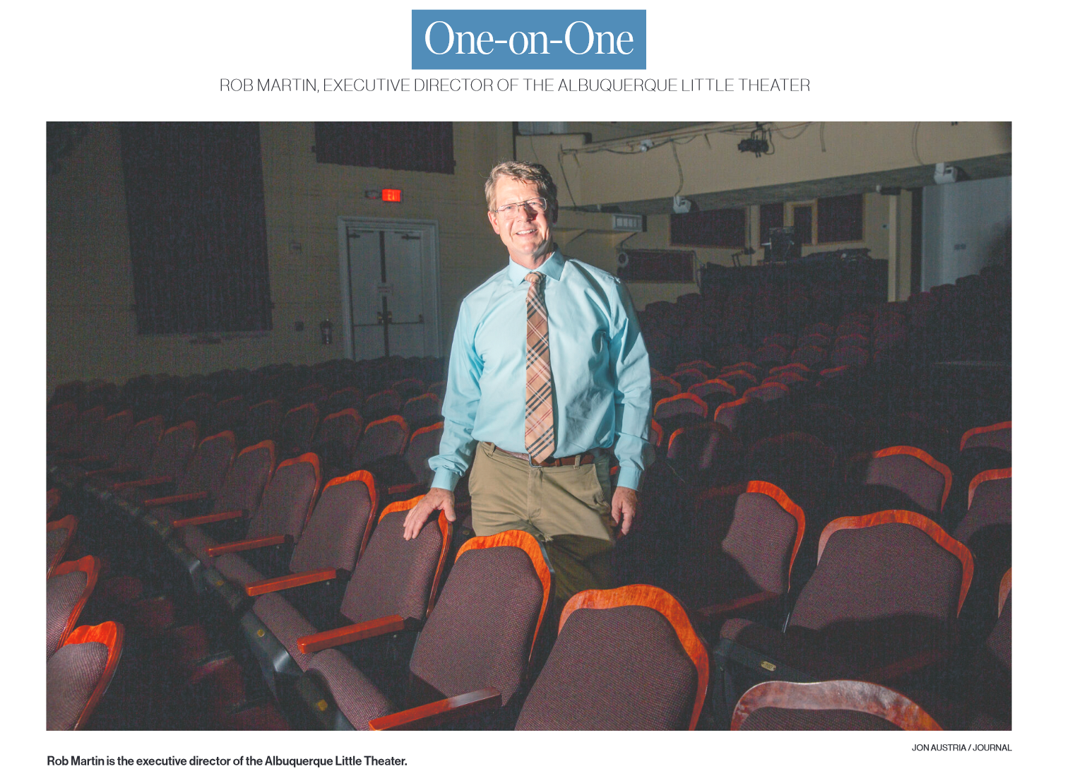
THE BASICS: Robert Armstrong Martin, 59, born in Albuquerque; one dog, Bambi,
Chihuahua-cattle dog mix; anticipated Ph.D. in education, Phoenix University, 2025;
master’s in business administration, Yale School of Management, 2014; bachelor’s
degree in drama/English, Dartmouth College, 1988.
POSITIONS: Executive director, Albuquerque Little Theatre, since July 2024, and
managing director, April to June 2024; New York University Long Island School of
Medicine, assistant dean, director of Continuing Professional Development and
faculty instructor, 2019-2024; NYU Winthrop Hospital, assistant dean, director of
continuing medical education, 2015-2024; Scientiae LLC, vice president, 2007-2015;
business intelligence manager (freelance), 2005-2007; TV and film actor, including
Saturday Night Live and four soap operas, 2004-2007.
OTHER: Committee member, Accreditation Council of Continuing Medical Education,
since 2019; board member, Theatre 2020, Brooklyn, New York, 2017-2020; board
member and Faculty Development Council chair, Association of Hospital Medical
Education, 2017-2020; volunteer actor, play development readings, The Drawing
Board 2012-2020; volunteer night ward staff, COVID-19 Intensive Care Telemetry Unit,
Winthrop Hospital, 2020.
JON AUST RIA / JOURNAL

BY ELLEN MARKS FOR THE JOURNAL
He had to dance around in 7-inch wooden hooves and a giant headdress with horns, and he loved it.
“It was so much fun,” said Rob Martin, of his lead role in “Beauty and the Beast” at the Albuquerque Little Theatre. That was more than three decades ago.
The professional performer and former health care educator, who is now running that same theater, remembers an even earlier experience.
He was 3 or 4 years old, he said, when his parents escorted him out to the ALT lobby because he was creating such a ruckus. The very young critic didn’t think the “Winnie the Pooh” characters on stage looked enough like those in books and on TV.
Martin’s long experience with the Country Club-area theater culminated July 1, when he was named its executive director. Before that, he was assistant dean at New York University Long Island School of Medicine and at NYU’s Winthrop Hospital.
Martin’s own early exposure to live performance is now among his goals for the 94-year-old theater, which Martin views as a contributor to New Mexico’s creative economy.
ALT’s roster of volunteers and kids who take classes and perform are learning skills that are transferable to the state’s burgeoning film industry, said Martin, who had some success as an actor in New York City and is now a playwright on the side.
“We see it as our job to prepare people for what could be their next career step,” he said. “We can be a feeder program for the hiring of locals … as opposed to carpetbaggers from L.A., who come (here) to work.”
Martin has a list of television, film and stage credits, and, besides acting, he can sing and dance. He also boasts a skill that’s much more unusual.
“I don’t share this with a lot of people,” he said, “but I can do the splits.”
To prove it, Martin came out from behind his desk, dropped to the floor and executed a perfect performance.
When did you first become interested in theater?
“We moved around a little when I was a kid, and I was always having to make new friends in new schools. And I was really introverted, but I was great at reading aloud. So much so that it would get me beaten up on the playground.
There was a really legendary drama teacher at Eldorado High — George Nason — and he was really an early mentor. I came out of my shell doing those classes and shows.
We didn’t really know how to connect to the acting profession out here in Albuquerque in the ‘80s. But at least a college drama degree seemed like a viable thing because of the tender loving care we got from that program at Eldorado. Avowedly, I was pre-med slash acting, which is not a thing. When I got to college, I was like, ‘Screw the pre-med.’”
How will you promote ALT as part of the state’s creative economy?
“Our sponsorship opportunities are key to this — partnering with large corporations to underwrite some of the costs of the show. They’ll get visibility benefits … in our education program, on the kids’ show T-shirts, souvenir cups, etc.
ROB MARTIN from page Z4
We also want them to help us get the word out by distributing tickets internally to their staffs. Theater tickets have become a very big staff well-being benefit back East. I think that model really works.”
Why did you shift from acting to health care?
“Interestingly, every actor who wants to be famous and moves to New York needs to find a really good day job. And I just fell into temp work that became ad agency work, and it happened that the ad agency I was in was very pharmaceutical client-focused.
We were doing a lot of medical training events, which sort of got me into the educational piece of health care, and I really liked that. Like many actors, you get to an age that if you’re not already famous, the work may get less and less for you because casting is very much driven by your type and your look.
So I just went with where the money was for those years but still acted.”
How do you spend your free time?
“I still love to perform. I’m meeting tomorrow night with a lady who wrote a show last fall that I was in, and she wants to write a sequel.
My playwriting — I’m always submitting to contests — and I do like to perform. I just don’t like to memorize gigantic plays.
My mom and I share this little dog that was a rescue. She’s a Chihuahua-cattle dog mix, so she may as well be a cat. She jumps up and walks around on top of things.”
What makes you successful?
“I have this strange ability to have new ideas constantly. Just crazy new ideas. Like what would happen if ...?
It’s really been on the business side of my career that I began to allow it and listen for it and not think it was just a weird voice in my head.
Writing ideas down means you don’t have to use them right away. That’s really helped me because I’m a relentless note-taker, and then it’s always saved and I don’t have to use my brain to store it. I can use my brain to make it better.”
Who are your role models?
“George Nason, may he rest in peace, is a huge role model for keeping a group engaged in theater.
Henry (Avery, Martin’s predecessor), who I’ve only known for three or four months, is a role model for his ability to keep this theater alive.
Actors who write, and writers who act. They’re all over the place.
Saturday Night Live, stand-up comics — they’re my role models for having the courage to write down an idea and having the courage to be the one to perform it. I think that’s really noble.”

